How to Add an Instructor Information Block

Why add an Instructor Information block?

At NorQuest College it is a requirement to have an Instructor Information Block in every course. The student opening a Moodle course wants to be able to identify their instructor and know how to contact them with ease. The Instructor Information block should be located at either side of your course page. At a minimum, the Instructor Information Block should include your name, office phone number and email address. It is recommended you put a photo of yourself in this block as well. Having an Instructor Information block is the first step in creating an online instructor presence.

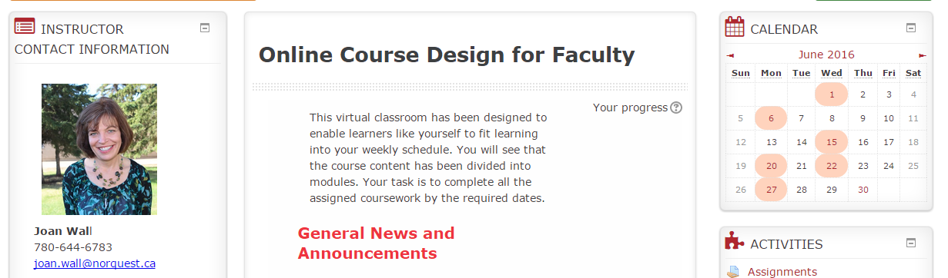

Steps to Create an Instructor Information Side Block

- Turn editing on at the top left of course page.
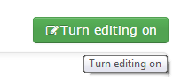

- Add an HTML Block:

Scroll down to the Add a Bock block and choose HTML from the drop down menu.
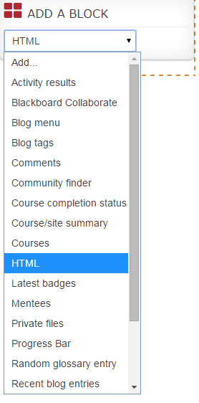

The course page will automatically refresh and a New HTML Block will appear, just before the Add a Block block. Note: An HTML block is a standard block that allows you to add text or multimedia to the sidebar of your course.
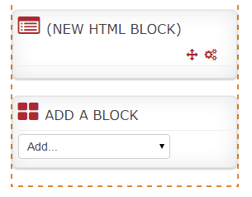
- Edit the HTML Block:

To edit an HTML block, click on the edit icon (gear) for that block.
Select Configure (new HTML block) block from the menu.

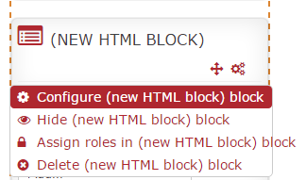

- Entering Instructor Information:

Block Title: Use “Instructor Info”. Anything longer than this title is permissible, but the title will be spread between 2 lines. This short title works well.
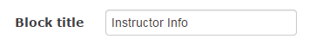
- Content: Picture
1. To include a picture, select the picture icon. You will be able to select a picture saved to your computer (recommended) or the Internet.

2. Click on Find or upload an image.

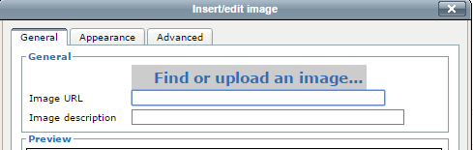
2

3. Click on Upload a file.
4. Choose File. 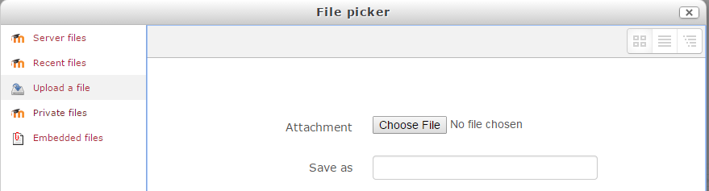
4
3
5. Navigate to the picture on your computer.

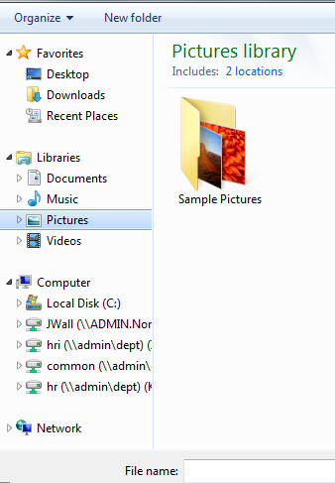

6. Select the file and click Open.

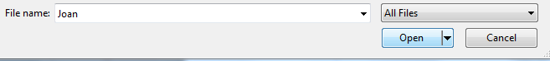
6

- Your document name will appear beside the Choose File. Give the document in the text box a name and click Save as to have this picture saved in Moodle. (You can use this picture in other courses under Moodle Recent Files.

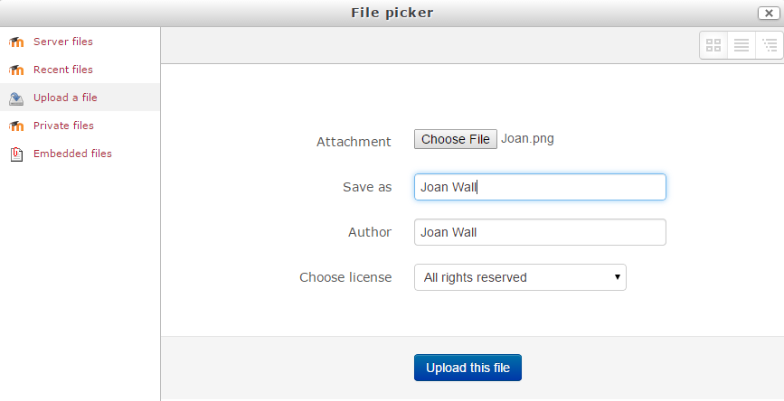
7

- Upload this file.

- Give an Image Description. This is important for anyone using a document reader. Having courses designed for universal needs is an important NorQuest Moodle course design principle.

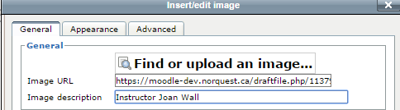

- Resize your picture.

Click on the Appearance Tab. Set the First Dimension within this range 175-250. (The second dimension automatically resizes.) If you select a smaller sized picture you may have to set Alignment to middle.) Select Insert.

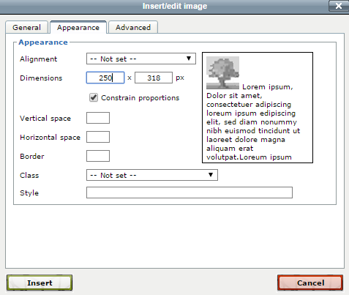

Instructor Information Content Considerations
You do not have to use titles (Name, Phone Number…) in this block. Eliminating titles for the information you are providing in this block reduces the length of this block.

Bold your Name.

Use Ctrl and Enter to single space the instructor information. Moodle double spaces by default.

Consider hyperlinking your email address.
1. Highlight your name.
2. Select the hyperlink icon.

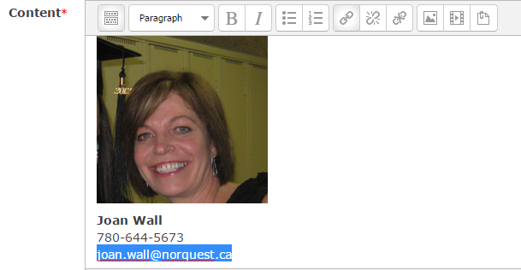

3. Put your email in the Link URL text box.
4. Give your email address a Title for people using text readers.
5. Select Insert.

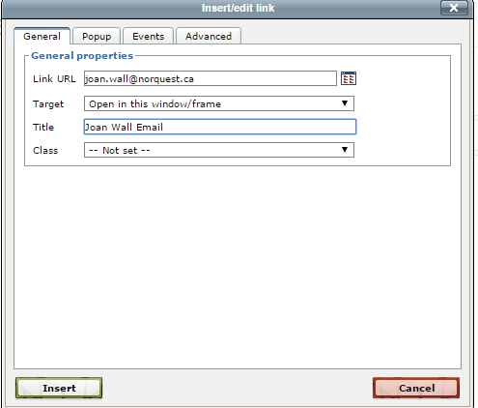

6. A dialogue box will appear to ask if this is an email address and to insert the ‘mailto:’ prefix. Select OK.

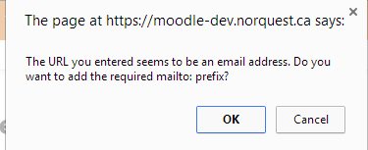

- Moving the Instructor Info Block to the Top of Your Course Page.

You may open the dialogue box Where this block appears. However, the easiest method of moving the Instructor Info block is to Save Changes and use the Move icon to drag it to the top of your course page.
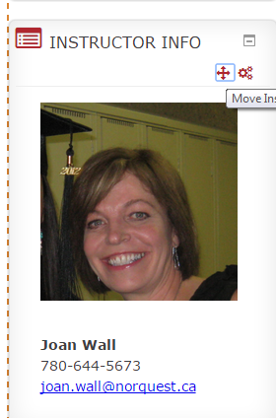

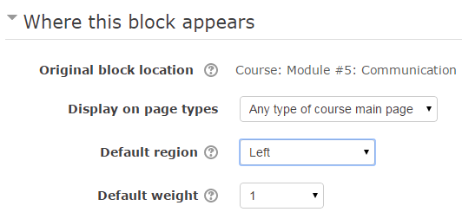

Questions? Please email Moodle Help <Moodle@NorQuest.ca>

